**Big data Analytics**

# **CS5590BD**

**Lab-6 Assignment**

BY

L V SANDEEP, BATHINA

JEEVANA, TUNUGUNTLA

BEERAVALLI, RAMAKRISHNA REDDY

GOUTHAM, MARIKANTI

# Task 1

* **Activity Summary:**

As per the project, we have implemented the game ‘2048’, by using 4 gestures namely:

* Left
* Right
* Top
* Bottom

We have included the below code for the senor tag to work with the above motions.

if (“up”.equalsIgnoreCase (data)) {

view,swipeUp();

}

Similarly the above code is reproduced for Down, Left and Right gestures.

Run the above code by enabling Bluetooth service and Debugging Mode on the mobile device. The motions from the senor tag get detected as below:

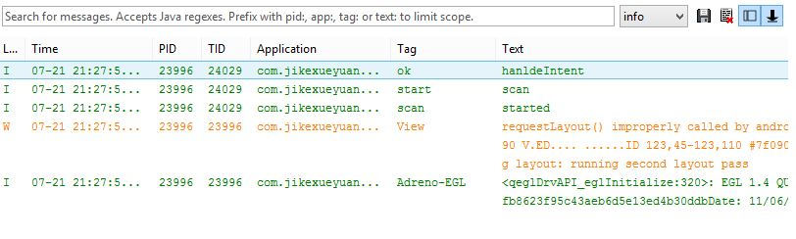

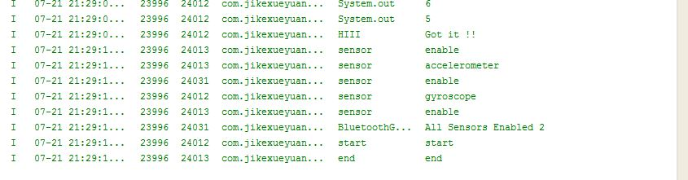

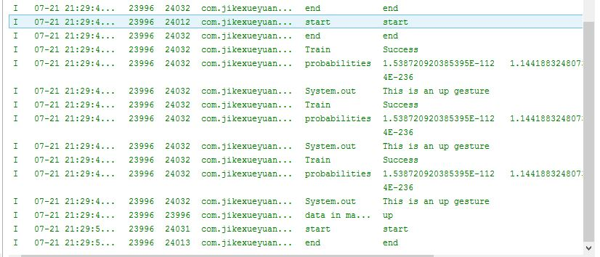

# Task2

* **Activity Report:**

We have included a “REPORT” button in the welcome screen of the game as follows:

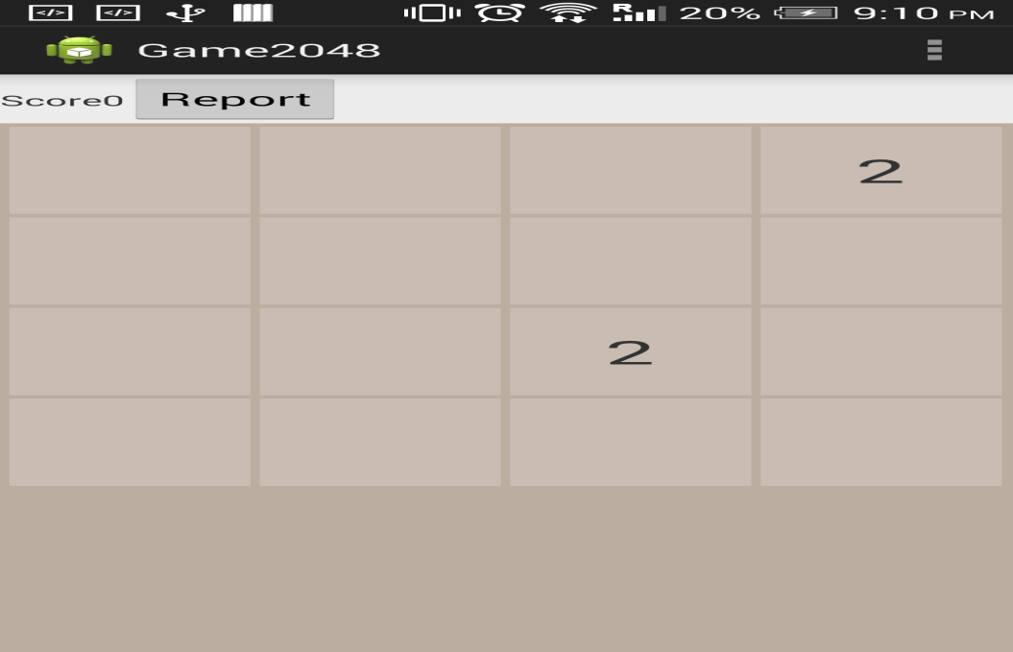

On clicking the above ‘Report’ button, the following screen will get displayed. In this screen, we have included a drop down menu having different days of the week for the user to choose from.

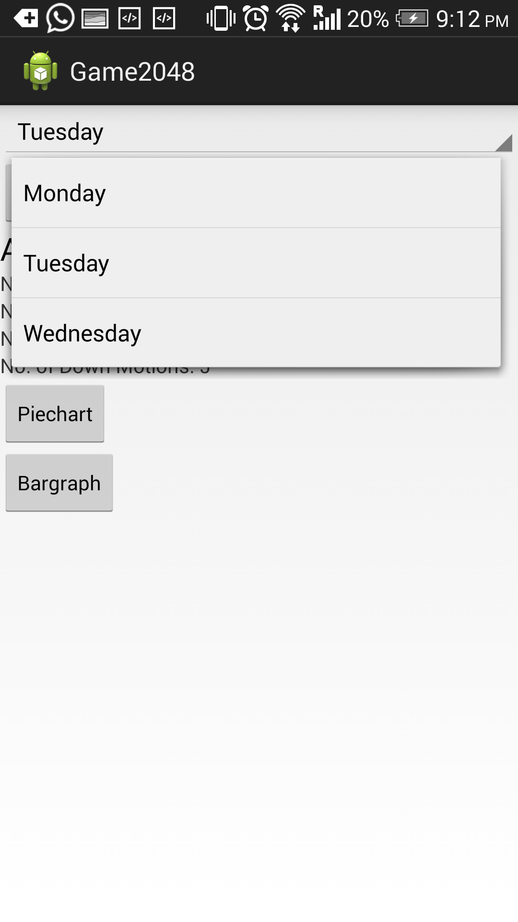

When the user chooses a particular day from the list, the activity report will be displayed as below:

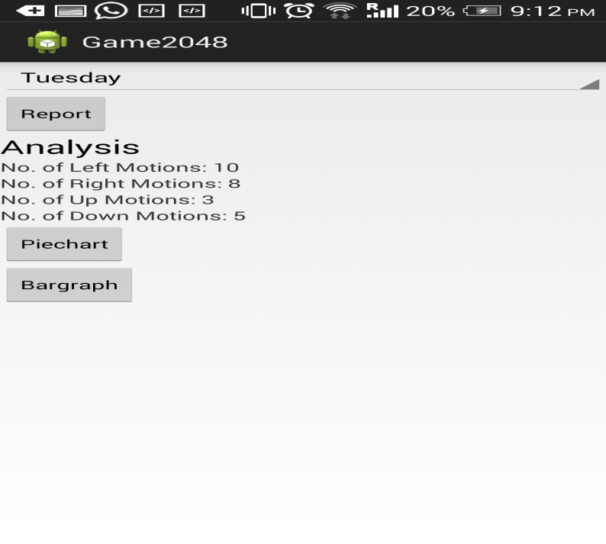

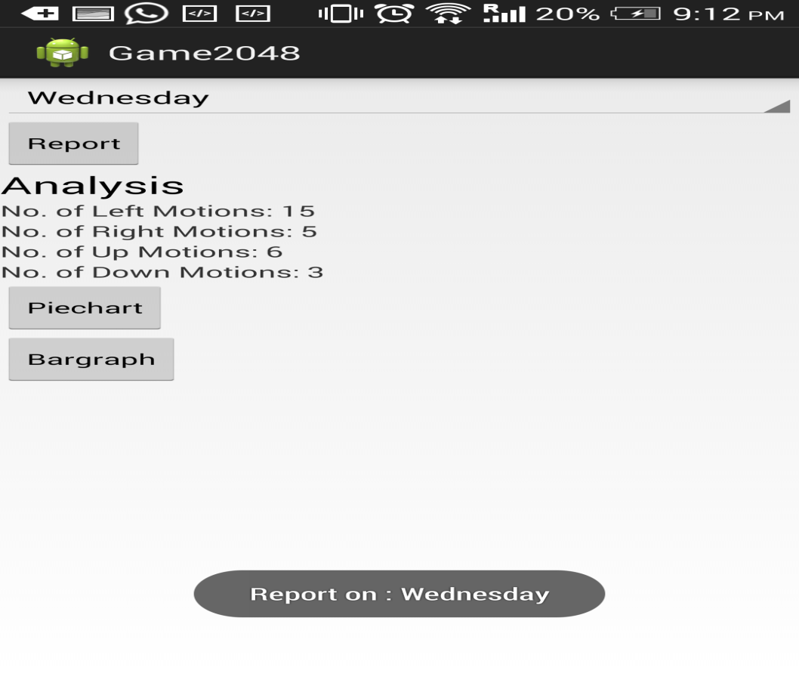

# Task 3

* **Graphical Report (Bar Graph, Pie Chart) :**

When the user selects a particular day and clicks on “Bar Graph button”, the corresponding day’s graph will be displayed with X-axis plotting the dates and Y- axis plotting number of motions corresponding to the gestures the user performs using the sensor tag.

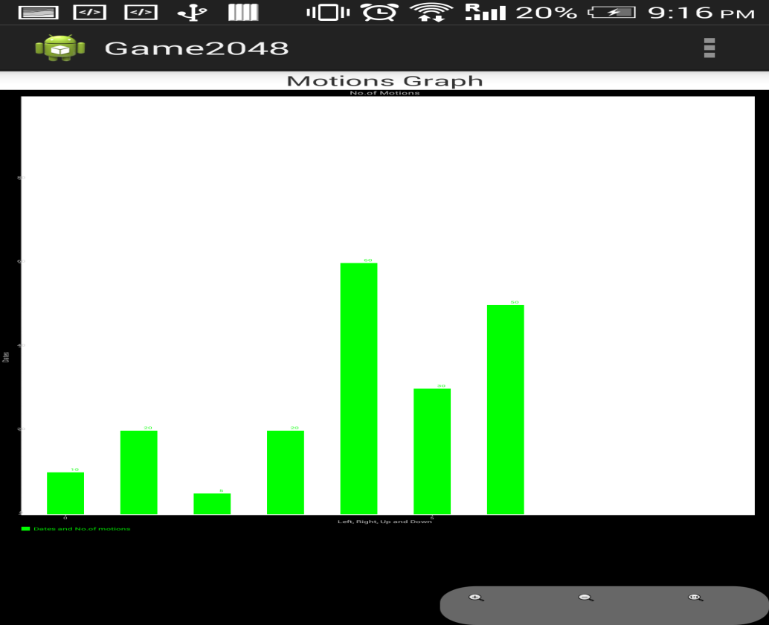

Similarly when the user selects a particular day and clicks on the ‘Pie Chart’ button, a pie chart displaying the percentages of each of the four gestures as below:

